**Ans 1. sudo apt install git**

**git config --global user.name "Abhishek Pandya"**

**git config --global user.name "**[**abhishekpandya5@gmail.com**](mailto:abhishekpandya5@gmail.com)**"**

**mkdir repo**

**cd repo**

**git init**

**Ans.2 git init**

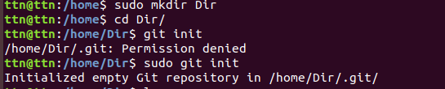

**Ans.3 sudo touch sampleFile**

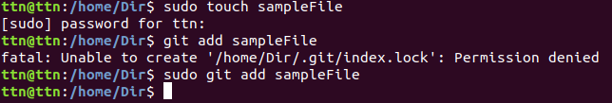

**Ans.4**

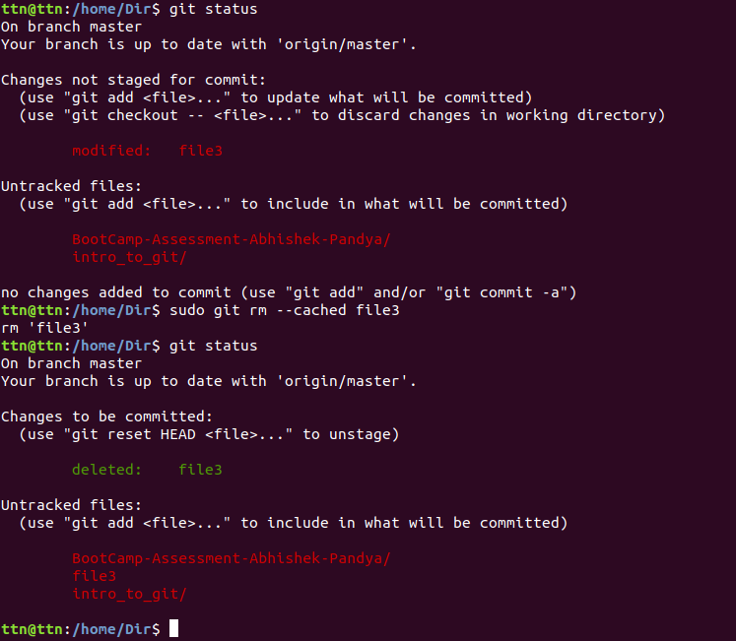

**Ans.5**

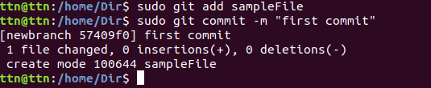

**Ans. 6**



**Ans.7 sudo git reset --hard**

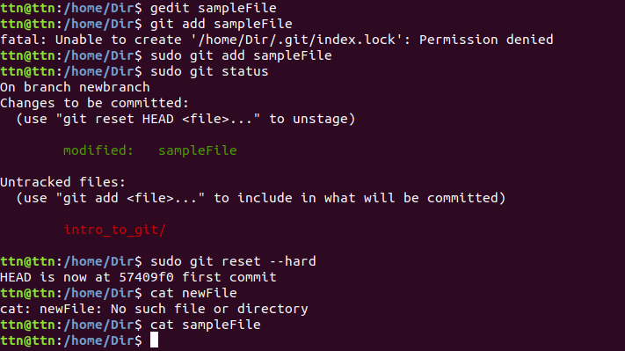

**Ans.8**

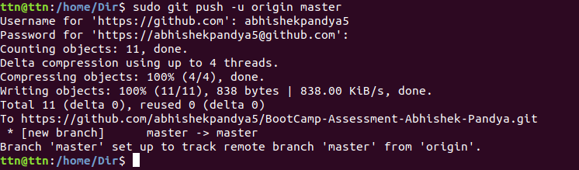

**Ans.9**

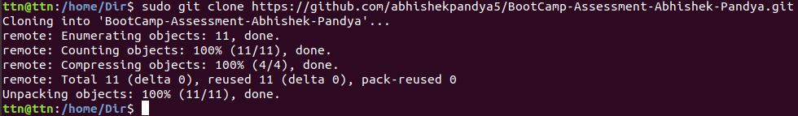

**Ans.10**

**Step 1: In the cloned directory edit file3 with some text as:**

**sudo echo "Adding some text" >> file3**

**Step 2: Commit and push the modified file on the server.**

**sudo git add file3**

**sudo git commit -m "commiting for ques 10"**

**sudo git push**

**Step 3: Now change directory and pull the last modified file from repository to the local directory.**

**sudo git fetch**

**sudo git pull**

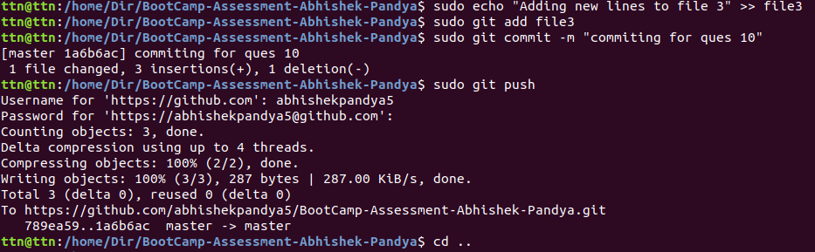



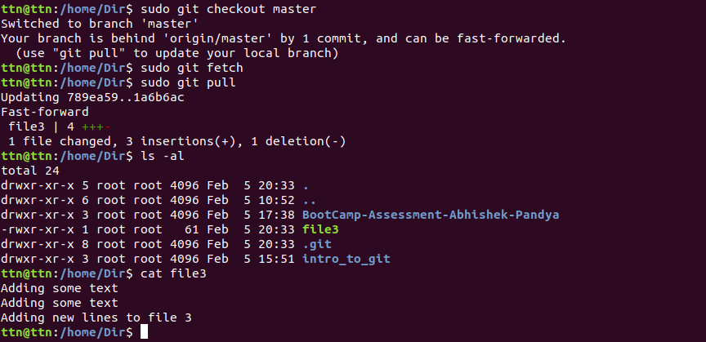

**Ans.11**



**Ans.12**

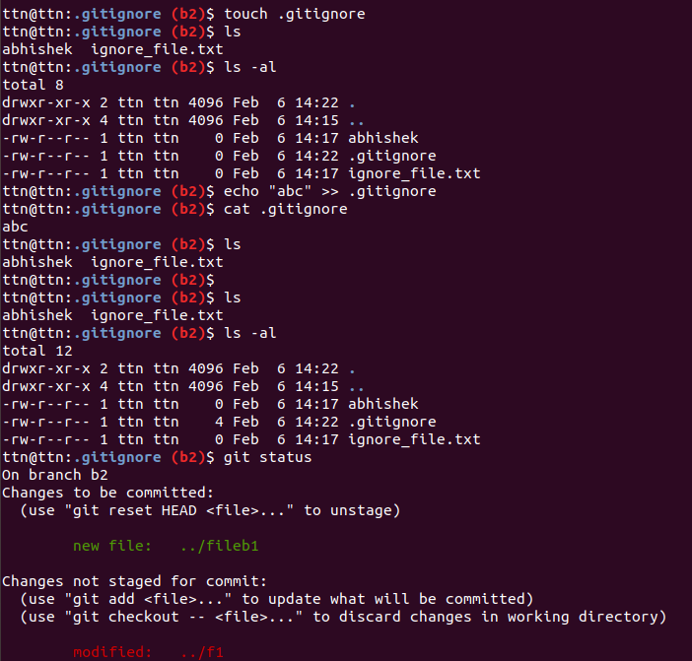

**Ans.13**

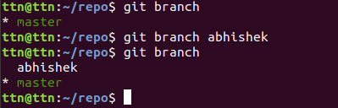

**Ans.14**

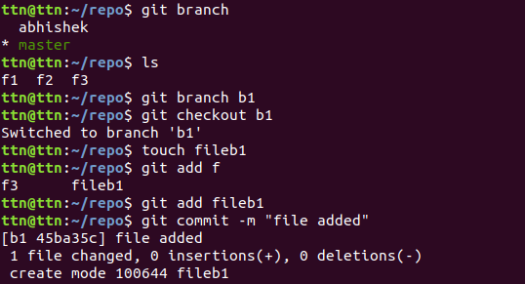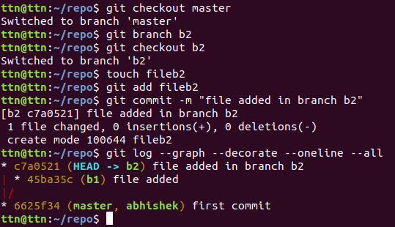

**Ans.15**

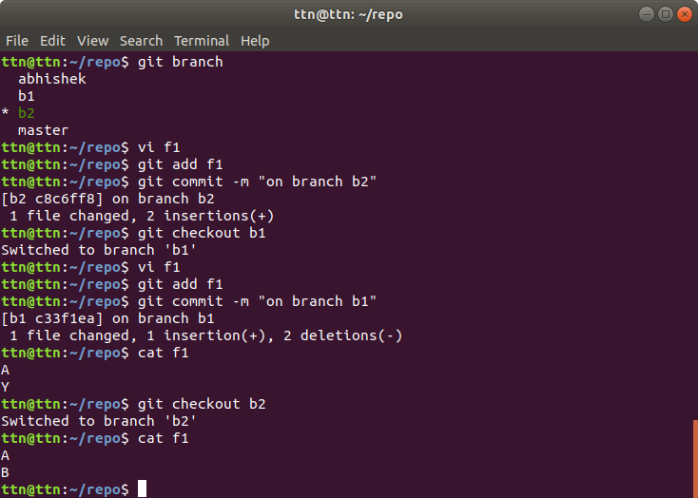

**16.**

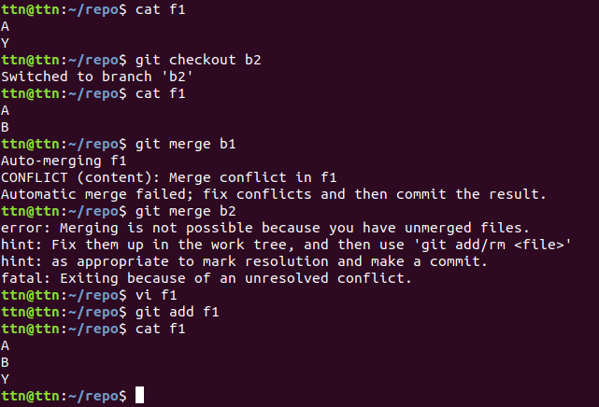

**17.**

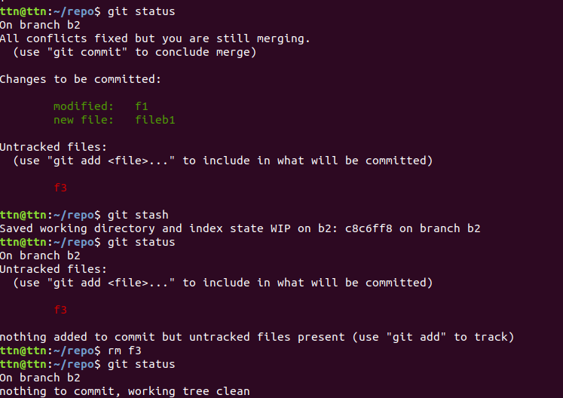

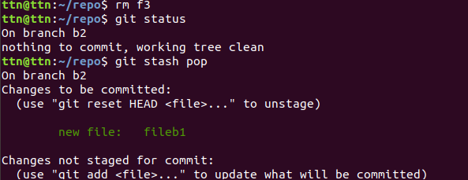

**18.**

